System Design details :

1. Restful Api’s are developed using Spring boot Rest controllers. It uses Tomcat as the default embedded container.
2. Security : Spring security is used for authentication and authorization. JWT authentication has been implemented for securing the exposed REST API.
3. RestTemplates are used to access Fractal API’s.
4. Java8 streams have been used to implement the logic to categorize transactions.
5. Bean Validation API 2.0 (JSR 380 ) has been used for validation and exception handling .
6. Not using any DataBase as dataset is from Fractal API, update API results can been seen only in the results .
7. Swagger UI has been integrated using Springdoc-openapi
8. JUnits 5 are used with mockito

Components Used :

1. Spring Security

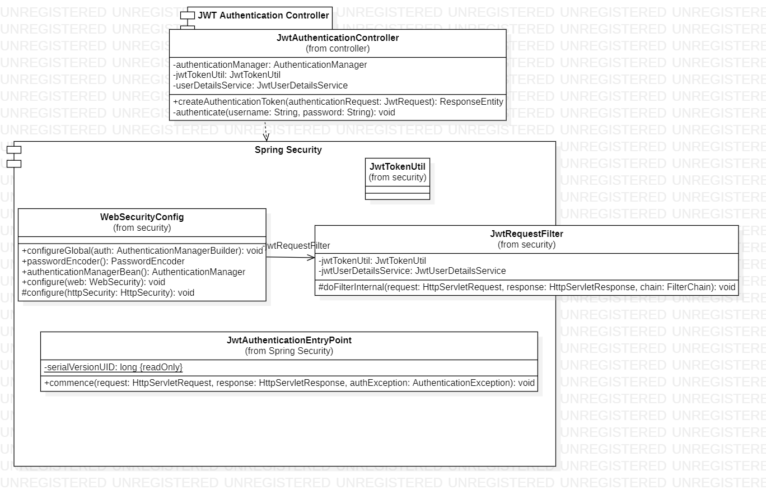

1. Rest Controllers

